**SOFTWARE DEVELOPMENT LABORATORY**

**EXPIMENT 6:**

**SCHEDULE THE SPRINT REVIEW**

**AIM:**

To schedule the sprint for the review after done the task. An important part of the scrum process is the sprint review meeting. The first part of this process is showing demos to the stakeholders. The second part of the process is the retrospective, which is sometimes called the reflection.

**PROCEDURE:**

In the Monday.com website sign up with email and password and create the project with the necessary details.

Open the release log by entering the project name and review the progress of the work in release log and in the sprint.

After the demos are shown to stakeholders, add feedback and comments about the review to the sprint plan

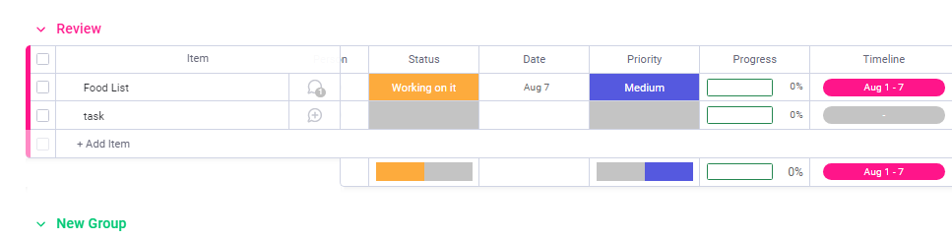

The task can be drawn from sprint to the review and the date can be fixed to review the sprint after all things is done by the team members.

Then the sprint can be processed and the sprint can be reviewed and the satisfactory reviews can be updated by sending the update message for the task.

The next part of the sprint review meeting is the retrospective, or reflection. The team discusses what went well, what did not go well, and what they plan to do.

To schedule the reflection meeting and track the team's comments and plans, use the Retrospective work item type, which is part of the Scrum process template.

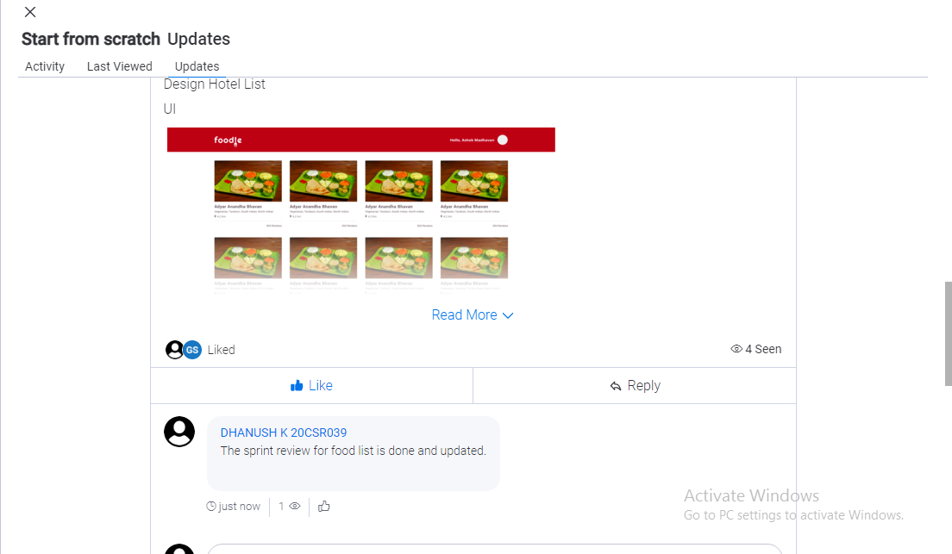

**CONCLUSION:**

Team members can add thoughts to the Discussion section, and the team can review the discussion at the meeting.